CO1 ASSESEMENT -1
SOFTWARE ENGINEERING
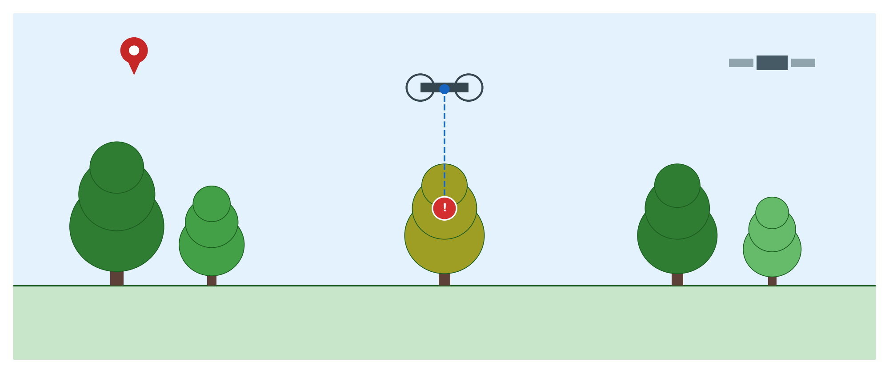
Smart AI-Based Urban Tree Health Monitoring
and Green Space Management System
Course Code: CSA -1017 Software Engineering
Submitted by: Divya Prashanth S
Program: B.Tech Information Technology (2nd Year)
Institution: SIMATS, Chennai

Industry Context
Urban forests and green spaces play a critical role in improving air quality, supporting biodiversity, and building climate resilience in growing cities. As urbanisation accelerates, municipal authorities face increasing pressure to manage large numbers of trees and green spaces with limited manpower. Advances in artificial intelligence, drone technology, satellite imagery, Geographic Information Systems (GIS), and the Internet of Things (IoT) now make it possible to monitor environmental and vegetation conditions continuously and at scale, rather than relying solely on periodic manual inspection.
This report presents a case study analysis of a proposed Smart AI-Based Urban Tree Health Monitoring and Green Space Management System. It follows the structure of problem understanding, stakeholder analysis, current-system evaluation, proposed solution design, methodology justification, and expected outcomes, applying core software engineering principles throughout.

1. Problem Analysis

1.1 Problem Statement Explained
Urban trees are essential to city life — they clean the air, moderate temperature, support biodiversity, and improve the overall quality of urban living. However, monitoring the health of these trees today is almost entirely manual. Forest and horticulture staff physically walk through parks, avenues, and green belts to check for disease, pest infestation, and stress caused by pollution or climate change. This process is infrequent, slow, and heavily dependent on the availability of trained personnel.
Because of this manual, resource-intensive approach, problems are often detected only after they have progressed significantly — by which point a tree may already be beyond saving, or a pest infestation may have already spread to neighbouring trees. Over time, this results in a steady decline in urban green cover, loss of biodiversity, and increased long-term cost for municipal bodies who must remove and replace dead trees rather than treat them early.
The proposed solution is an AI-powered platform that continuously monitors urban trees using drone imagery, satellite data, and IoT environmental sensors. It automatically analyses this data to detect disease and pest symptoms, track growth patterns, identify environmental stress factors, and generate maintenance recommendations — all mapped onto a GIS-based system so municipal authorities know precisely which tree, at which location, needs which type of intervention.

1.2 Objectives of the Proposed System
- Continuously monitor the health of urban trees instead of relying on periodic manual inspection.
- Use AI/ML models on drone and satellite imagery to detect diseases and pest infestations at an early stage.
- Analyse tree growth patterns over time to assess development and canopy health.
- Identify environmental stress factors such as pollution, soil degradation, water stress, and heat stress.
- Automatically generate maintenance and intervention recommendations for field staff.
- Integrate GIS-based mapping so every tree is geo-tagged and traceable in a central database.
- Improve the overall efficiency of urban green space management for municipal authorities.
- Support long-term environmental sustainability and biodiversity conservation goals of the city.

1.3 Scope of the Problem
The scope of this system covers urban and semi-urban green spaces under municipal or forestry department jurisdiction — including roadside avenue trees, public parks, green belts, and urban forest patches. It covers the technical scope of data acquisition (drones, satellites, IoT sensors), AI-based analysis (disease detection, growth analysis, stress identification), and management functions (GIS mapping, recommendation generation, dashboards for staff and citizens).
The scope does not extend to fully autonomous tree treatment (e.g., robotic pesticide spraying) in its first phase — the system is designed as a decision-support and monitoring platform that informs and directs human field teams, rather than replacing them. It is scoped for deployment at a city or district level, with the underlying architecture designed to scale to state-wide urban forestry programs in later phases.

2. Stakeholder Analysis

2.1 Key Stakeholders
The system involves a range of stakeholders across government, technical, and community groups, each with a distinct role in the successful operation of the platform:
Stakeholder | Role / Responsibility | Key Challenge Faced
Municipal Corporation / Urban Forestry Dept. | System owner; sets policy, allocates budget, oversees green space management city-wide. | Limited manpower and budget for frequent manual inspection of thousands of trees.
Forest / Horticulture Field Officers | Carry out on-ground maintenance, pruning, pesticide application, and tree removal based on system recommendations. | Difficult to prioritise which trees need urgent attention without data support.
Drone / GIS Survey Operators | Capture aerial imagery and maintain the geo-tagged tree database. | Weather constraints, flight permissions, and data volume management.
AI/Software Development Team | Build, train, and maintain the disease-detection models, GIS platform, and dashboards. | Need large, high-quality labelled datasets of tree disease/pest imagery for training accurate models.
Environmental Scientists / Botanists | Validate AI detection results, define disease categories, and advise on treatment protocols. | Bridging domain botanical knowledge with AI/ML model design.
Citizens / Resident Welfare Associations | Report visibly damaged or diseased trees; benefit from healthier green spaces. | Limited awareness or channel to report tree health issues to authorities.
NGOs & Environmental Researchers | Use aggregated data for biodiversity studies and conservation planning. | Need standardised, open access to non-sensitive monitoring data.
IT Infrastructure / Cloud Providers | Host the platform, sensors network, and ensure data storage and uptime. | Managing large-scale image and sensor data reliably and securely.

2.2 Major Challenges Faced by Stakeholders
- Scale: A single city may have hundreds of thousands of trees, making manual inspection by field officers practically impossible to do frequently.
- Data availability: Building accurate AI disease-detection models requires large labelled datasets of tree health imagery, which are not always readily available for local species.
- Coordination: Multiple departments (forestry, municipal IT, environmental agencies) must coordinate, which can slow down adoption of a shared digital platform.
- Awareness: Citizens are often the first to notice a visibly sick tree but have no easy channel to report it to the right department.
- Budget constraints: Drones, sensors, and cloud infrastructure require upfront investment that smaller municipal bodies may find difficult to justify without clear ROI.

3. Analysis of the Current Approach

3.1 Existing Process
Today, urban tree health monitoring is a largely manual and reactive process. Municipal horticulture or forestry staff conduct periodic ground surveys — often only once every few months or after a citizen complaint — walking through parks and avenues to visually inspect trees. Any diseased, pest-infested, or structurally unsafe tree identified is noted manually, sometimes on paper registers or basic spreadsheets, and reported up the chain for maintenance action.
Tree location records, where they exist, are frequently outdated or incomplete, and there is little to no continuous environmental data (soil condition, pollution exposure, water stress) linked to individual trees. Maintenance decisions are largely based on visible symptoms and the personal experience of field staff rather than data-driven analysis.

3.2 Strengths of the Existing System
- Low technology dependency — does not require significant digital infrastructure or specialised training.
- Field officers bring valuable practical, on-ground experience and contextual knowledge of local species.
- Low direct cost, since it relies on existing staff rather than new hardware or software investment.

3.3 Limitations and Gaps
- Infrequent monitoring means diseases and pest infestations are often detected only after significant damage has occurred.
- No systematic, city-wide database linking each tree to its exact location, species, age, and health history.
- Lack of quantitative environmental data (pollution levels, soil moisture, temperature stress) to explain why a tree is declining.
- Manual records make it difficult to analyse trends, plan budgets, or prioritise maintenance across a large number of trees.
- Heavily dependent on individual staff expertise and availability — inconsistent when staff are reassigned or unavailable.
- No structured channel for citizens to contribute observations, leading to under-reporting of issues.

4. Proposed Software Solution

4.1 Solution Overview
The proposed solution is a cloud-based, AI-powered Urban Tree Health Monitoring and Green Space Management Platform. It continuously ingests data from drones, satellite imagery, and IoT ground sensors, processes it through AI/ML models to detect disease, pests, and environmental stress, and presents actionable insights through GIS-based dashboards to municipal staff, while also enabling citizen reporting.
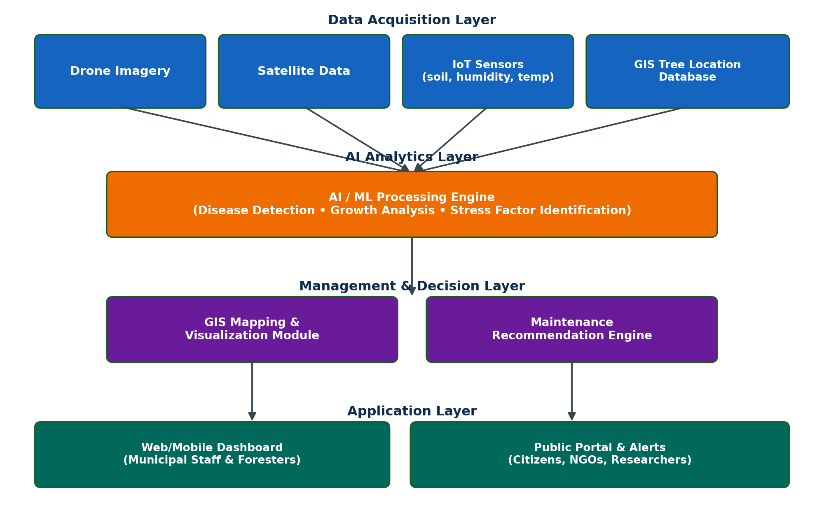

4.2 Major Functional Modules
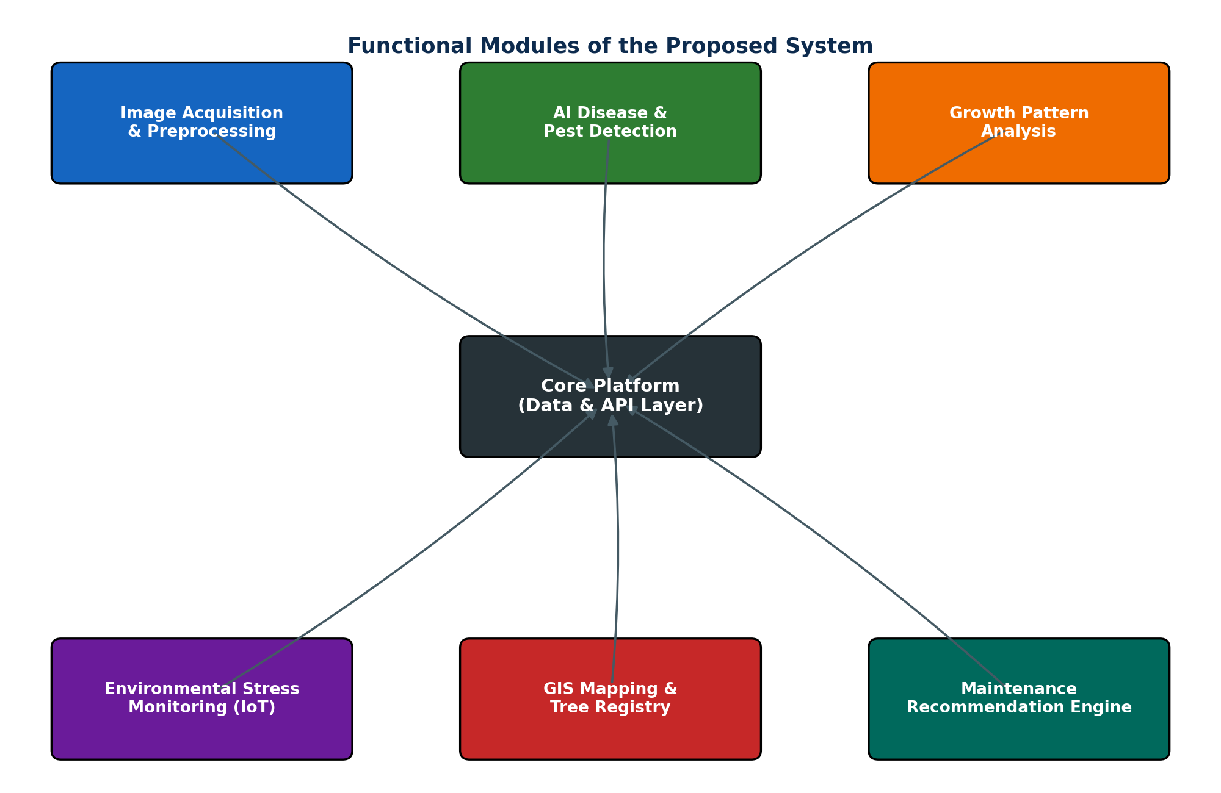

- Image Acquisition & Preprocessing Module — collects and cleans drone/satellite imagery for analysis.
- AI Disease & Pest Detection Module — applies trained computer-vision models to flag disease/pest symptoms.
- Growth Pattern Analysis Module — compares imagery over time to track canopy growth and decline trends.
- Environmental Stress Monitoring Module — processes IoT sensor data (soil moisture, temperature, pollution) per zone.
- GIS Mapping & Tree Registry Module — maintains a geo-tagged database of every tree with its health history.
- Maintenance Recommendation Engine — converts detected issues into prioritised, actionable maintenance tasks.
- Dashboard & Citizen Reporting Module — web/mobile interface for municipal staff, plus a simplified public interface for citizen reports and alerts.

4.3 Functional Requirements
Functional requirements describe what the system must actually do — the specific capabilities visible to its users:
ID | Functional Requirement
FR-1 | Capture and store drone and satellite imagery linked to specific GIS coordinates.
FR-2 | Analyse imagery using AI models to classify tree health status (healthy, stressed, diseased, critical).
FR-3 | Ingest real-time data from IoT sensors (soil moisture, temperature, air quality) deployed across green zones.
FR-4 | Generate maintenance task recommendations and assign them to specific field officers.
FR-5 | Allow citizens to submit photo-based reports of tree issues through a mobile or web interface.
FR-6 | Provide dashboards with filters by zone, species, health status, and maintenance priority.
FR-7 | Maintain a historical health record for every registered tree for trend analysis.

4.4 Non-Functional Requirements
Non-functional requirements describe the quality attributes and constraints the system must satisfy:
Quality Attribute | Requirement Description
Scalability | Must support monitoring from a single park up to an entire city's tree inventory without redesign.
Reliability | Sensor and imagery pipelines must handle intermittent connectivity in outdoor field conditions gracefully.
Usability | Dashboards must be simple enough for non-technical municipal field staff to use with minimal training.
Security | Tree location data and citizen-submitted reports must be protected against unauthorised access and tampering.
Maintainability | AI models and modules must be retrainable/updatable as new disease patterns or species are added.
Performance | Image analysis results should be available within a reasonable turnaround time to support timely intervention.

4.5 Application of Software Engineering Principles
Principle | How It Is Applied in This System
Modularity | The system is split into independent modules (image processing, AI detection, GIS, recommendations, dashboard) that can be developed, tested, and updated separately.
Scalability | Cloud-based architecture and microservices allow the platform to scale from one district to an entire city or state without redesign.
Maintainability | Clear module boundaries and versioned AI models make it easy to update detection logic as new tree diseases or species are added.
Reliability | Redundant data pipelines and offline-capable field apps ensure the system continues functioning despite network or sensor interruptions.
Usability | Role-based dashboards (simple map views for field staff, detailed analytics for administrators) are designed around each user's actual needs.
Security | Role-based access control, encrypted data storage, and secure APIs protect sensitive location and citizen data.

5. Methodology / Framework Justification

5.1 Selected Methodology: Agile (Scrum Framework)
The Agile methodology, implemented through the Scrum framework, is selected for the development of this system. Development is organised into fixed-length sprints (typically two weeks), each delivering a working increment of the system — for example, one sprint might deliver the image ingestion module, the next might integrate the AI detection model, and so on.
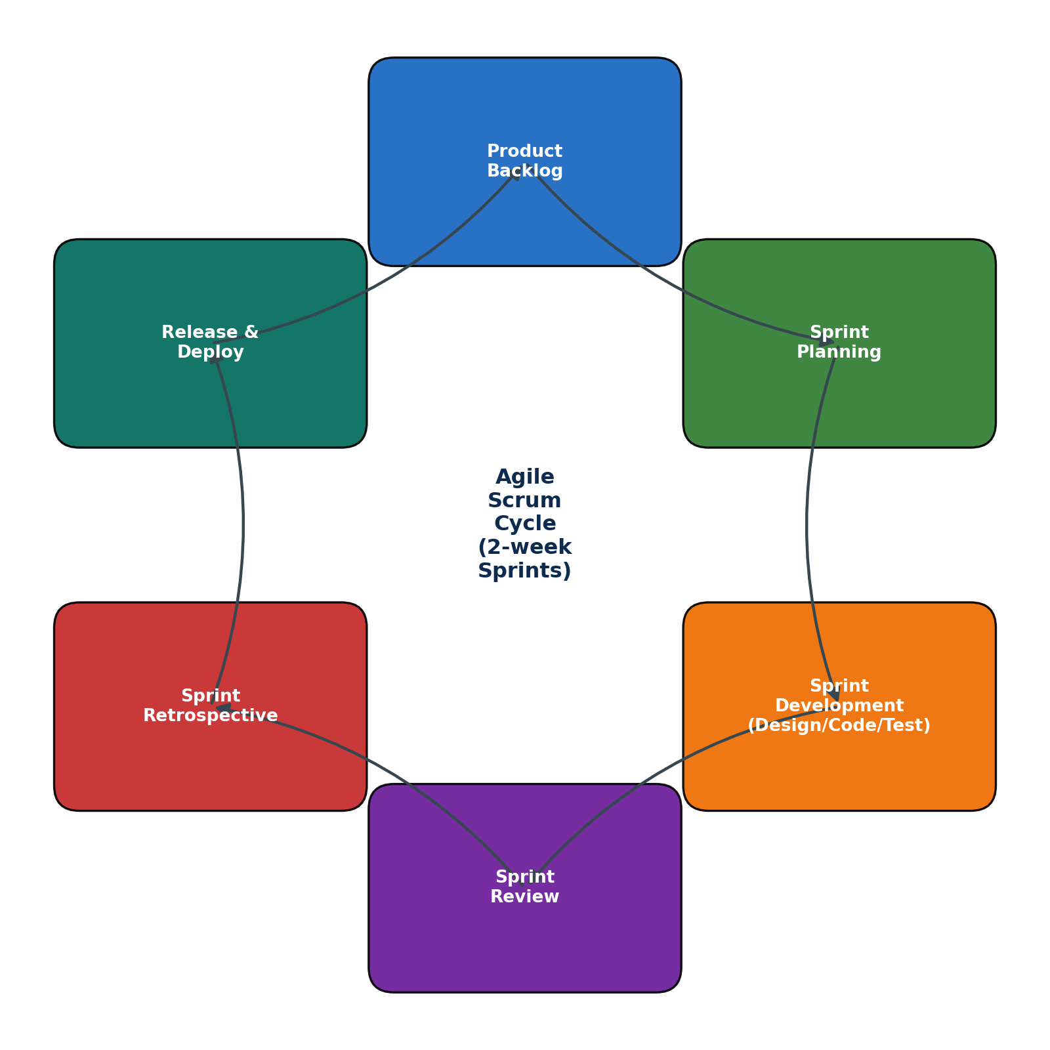

5.2 Justification for Choosing Agile/Scrum
- The system integrates several evolving technologies (AI models, IoT, GIS) whose requirements are likely to change as real-world data is collected — Agile's iterative nature accommodates this well.
- AI/ML components benefit from continuous feedback loops: models can be retrained and improved each sprint as more labelled tree-health data becomes available.
- Stakeholders (forestry officials, botanists) can review working increments every sprint and provide feedback early, rather than waiting until the end of a long development cycle.
- Modular architecture aligns naturally with Scrum's practice of delivering incremental, independently testable features (e.g., GIS module, then AI module, then recommendation engine).
- Risk is reduced because problems (e.g., poor model accuracy on a certain disease type) are surfaced early within a sprint rather than late in the project.

5.3 How It Supports Development and Maintenance
Sprint reviews allow environmental scientists and municipal stakeholders to validate whether AI detection results align with real botanical knowledge before further development continues. Sprint retrospectives allow the technical team to continuously refine data pipelines and model training practices. Post-deployment, the same sprint cycle supports ongoing maintenance — for example, adding support for a new tree species or a newly identified disease pattern can be handled as a scoped, time-boxed sprint rather than a disruptive full re-development effort.

6. Expected Outcomes and Limitations

6.1 Expected Benefits
- Improved overall health and survival rate of urban trees through early, data-driven intervention.
- Earlier detection of diseases and pest infestations before they spread to neighbouring trees.
- More efficient allocation of limited field staff and maintenance budgets, guided by prioritised recommendations.
- A permanent, queryable digital record of every tree's health history, supporting long-term urban planning.
- Increased citizen engagement and awareness through the public reporting and alert features.
- Reduced long-term costs by replacing expensive dead-tree removal and replacement with early treatment.

6.2 How the Solution Addresses Identified Challenges
The AI and drone-based monitoring directly addresses the scale problem — a small survey team can now cover an entire city's tree inventory far more frequently than manual walking inspections allow. The GIS registry solves the record-keeping gap by giving every tree a permanent digital identity and history. The citizen reporting module opens a channel that did not exist before, and the recommendation engine converts raw detections into prioritised, actionable tasks for field officers, directly addressing the earlier lack of data-driven prioritisation.

6.3 Potential Risks, Implementation Challenges, and Limitations
- AI model accuracy depends heavily on the availability of well-labelled local tree disease/pest image datasets, which may take time to build.
- Initial hardware investment (drones, IoT sensors, cloud infrastructure) may be a barrier for smaller municipal budgets.
- Weather conditions and flight regulations can restrict drone survey frequency in some regions.
- Coordination between multiple government departments (forestry, IT, municipal administration) may slow initial rollout.
- The system remains a decision-support tool — final treatment actions still depend on human field officers, so adoption and trust in the recommendations is essential for real impact.

6.4 Future Enhancements
- Integration of robotic or drone-based automated treatment (e.g., targeted pesticide spraying) for high-priority cases.
- Expansion to predictive analytics that forecast disease outbreaks before visible symptoms appear, using historical and climate data.
- Mobile app enhancements with AR-based visual overlays for field officers to see tree health data on-site.
- Broader integration with smart city platforms for combined air-quality, biodiversity, and green-cover analytics.
- Community/citizen-science expansion allowing verified public volunteers to contribute monitoring data at scale.

7. Conclusion
The Smart AI-Based Urban Tree Health Monitoring and Green Space Management System addresses a genuine and growing gap in city administration: the inability of manual, periodic inspection to keep pace with the scale of urban tree cover that needs protecting. By combining drone and satellite imagery, IoT environmental sensors, AI-based disease and stress detection, and GIS mapping into a single modular platform, the system moves urban forestry management from a reactive to a proactive model.
The proposed architecture applies core software engineering principles — modularity, scalability, maintainability, reliability, usability, and security — to ensure the platform can be built incrementally, adopted gradually by municipal bodies, and extended over time as new requirements emerge. An Agile/Scrum development approach was found most suitable given the evolving nature of AI model training and the need for continuous stakeholder feedback. While challenges such as dataset availability, initial infrastructure cost, and inter-department coordination remain, the expected benefits — healthier urban trees, earlier disease detection, and more sustainable green space management — make this a worthwhile investment for modern, environmentally conscious cities.

References
- Food and Agriculture Organization (FAO) — Guidelines on Urban Forestry and Green Space Management.
- IEEE literature on AI-based plant disease detection using computer vision and deep learning.
- Open Geospatial Consortium (OGC) — Standards for GIS-based asset mapping and spatial data management.
- Scrum Guide — Official Agile Scrum Framework documentation.
- Course materials and lecture notes — Software Engineering, SIMATS.

